|  |
| --- |
| **Exmark Parts Price File (Field Definitions), last updated 5/01/2023** |

Please make sure your data Processing Personnel and/or computer vendor receives and retains a copy of this document to help them interpret the data.

**Excel (Sample Data):**

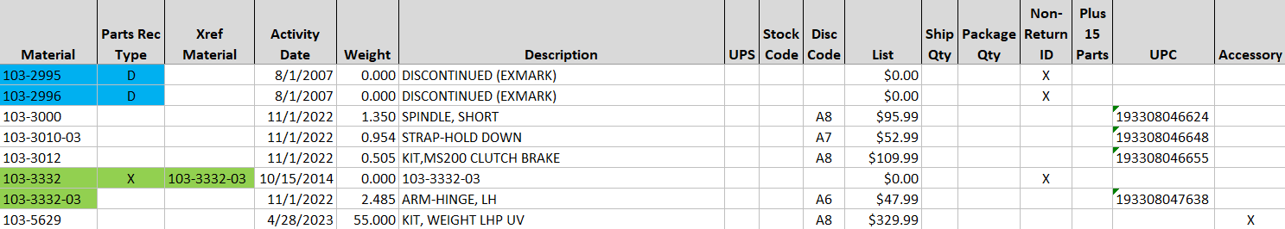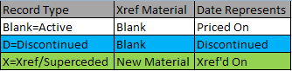

**Field Definitions:**

|  |  |  |
| --- | --- | --- |
| **Field** | **Length** | **Notes** |
| Material# | 18 | 1 |
| Part_Record_Type | **1** | 2 |
| Xref Material | 18 | 3 |
| Activity_Date | 8 | 4 |
| Weight (Pounds) | Numeric (3 decimals) | 5 |
| Description | 40 | 6 |
| UPS | 1 | 7 |
| Stock Code | 1 | 8 |
| Discount Code | 2 | 9 |
| List Price (MSLP) | Numeric (2 decimals) | 10 |
| Ship Qty | Numeric (Integer-3) | 11 |
| Package Qty | Numeric (Integer-3) | 12 |
| Non-Return_ID | 1 | 13 |
| Plus 15 Parts | 1 | 14 |
| UPC | 18 | 15 |
| Accessory | 1 | 16 |

**Notes:**

1. **Material Number (Formerly “Part Number”)**
2. **Part Record Type**

* **(X)** = Xref record.
* **(D)** = Discontinued record
* **(Blank)** = Active Item/Record.

**Very important note:**

List price and other field values are set to $0.00 or null for (X & D) records.

If you wish to retain existing price for (X & D) items make sure your program only updates (Active) records else pricing for (X & D) records, will be lost (overridden to zero).

1. **Xref Material**

* This represents the “new” or the superseding material.
* This Information is also repeated in the Description field.
* Xref Qty of 1, is always implied.

1. **Activity_Date**

* This field is populated from 3 different sources (See; Part Record Type):
* **Xref Activity** Date
* **Discontinue** Date
* **Price Effective** Date

1. **Weight in Pounds**

* Example; 103-3297 = 3.020 LB

1. **Description**

* Descriptions for Xref Materials will contain the superseding Material Number.
* Xref Quantity of one is always implied.

1. **UPS**

* This code = X means this item can not be shipped via UPS (or other small parcel carrier) due size or weight restrictions

1. **Changed 🡪 Stock Code**

* This code is derived from the 2nd character of the OMS field = Velocity Code (A2)

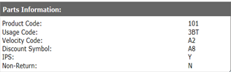

* Stock Codes (1-4) are as follows:
* 1-Fastest Moving
* 2-Fast Moving
* 3-Slower Moving
* 4-Slow Moving
* F-Field Fix

* Return Codes (Y/N) are no longer supported in this field—>See field= **Non-Return_ID**

**Notes (con’d):**

1. **Discount Codes**

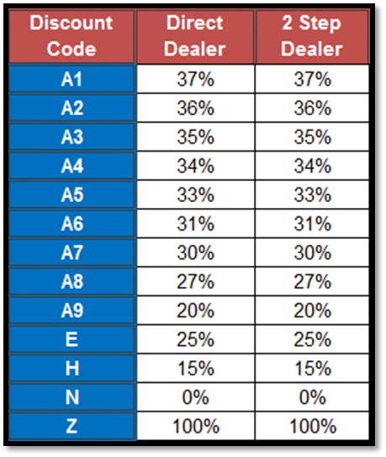

1. **LIST or (MSLP)**

* **Manufacturers Suggested List Price**

1. **Ship Qty**

* If populated for your customer group, orders for these materials will automatically roll up to the quantity listed.
* When the package quantity is blank it is assumed=1.
* Example if Qty=10, and your order qty is under 10 them order qty will increment up to next increment of 10, 20, 30 etc.

1. **Package Qty**

* This field is similar to 🡪**Ship Qty**
* This field will have additional items with a quantity, when our Parts Warehouse packages for shipping convenience.
* When the package quantity is blank it is assumed=1.

1. **New 🡪 Non-Return_ID**

* X values are not returnable
* A null value denotes the item is a candidate for return (*subject to annual return policies*)

1. **Plus 15 Parts**

* For Warranty purposes.

1. **UPC**

* Universal Product Code

1. **Accessory**

* X values are Exmark categorized accessories