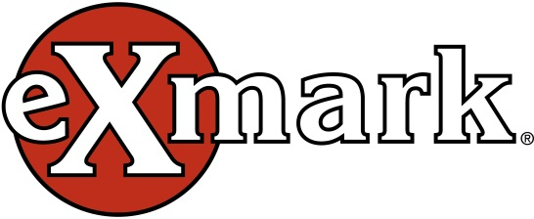

Exmark “Big Rock” Annual Project

Qualifications

Must be a 501(c)(3), a unit of government, or a school

Project must be within 30 miles of the Exmark facility

Project must be complete by October 31 of the year funds granted

Funding is up to $25,000

Focus is on beautification of grounds and outdoor recreation, specifically park areas

Submit by April 30, 2025 to:

[patty.kaufman@exmark.com](mailto:patty.kaufman@exmark.com)

Patty Kaufman 402-223-6300

Or

415 Industrial Row

Beatrice NE 68310

Exmark “Big Rock” Application Form

ORGANIZATION INFORMATION

Tax ID

Name of Organization Legal Name, if different

Address

City State Zip code

Phone Fax

Website Address

Is your organization an IRS 501(c)(3) not for profit?

If no, is your organization a public agency / unit of government or a school?

Organization History and Mission

Please provide a summary of organization history, mission and goals, including the date your organization was established.

Brief description of organization activities

Provide a list of Board members and their affiliations

List any Exmark employees involved with your organization and their involvement

List names of corporations and foundations from which you receive financial support

TOP PAID STAFF INFORMATION

First Name Last Name

Title

e-mail Office phone

CONTACT INFORMATION

First Name Last Name

Title

e-mail Office phone

PROPOSAL INFORMATION

Purpose of Grant

Geographical Area Served

Project start date Project end date

Project Title

Project Description

Outline the need for this project

Describe the specific activities for which you seek funding

Who will carry out these activities?

How will the proposed activities benefit the community in which they will occur?

Goals – Please outline the top 3 goals for this project

Budget Section

Requested amount (up to $25,000)

Annual Budget

Project Budget

Discuss the funding strategies for your project

List names of corporations and foundations from which you are requesting funds

Please include the following attachments:

1. Financial statement(s) from most recently completed year
2. Tax ID – a copy of your current IRS determination letter indicating tax-exempt 501(c)(3) status